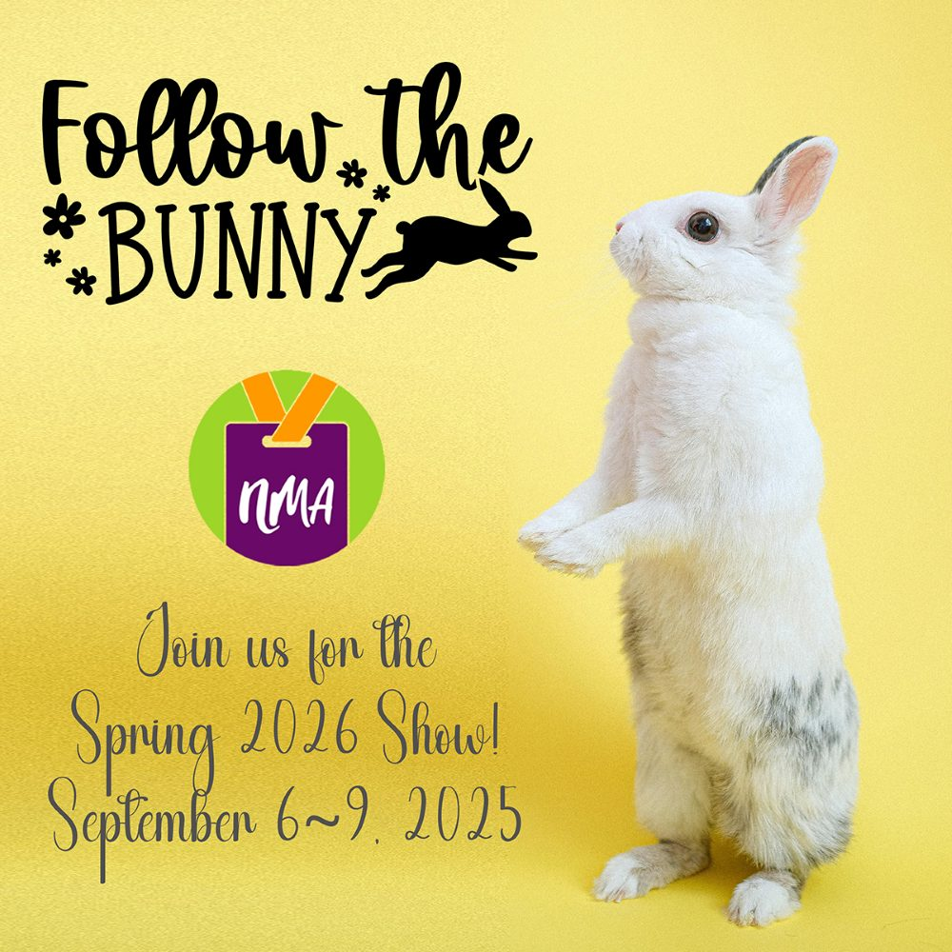

MARKET RULES AND REGULATIONS
SPRING 2026
SEPTEMBER 6-9, FOR SUITES AND BALLROOMS
SEPTEMBER 9, 2025, FOR BALLROOMS ONLY
Two-Day Show Suites: 9a - 6p Saturday, Sunday / 9a - 4p Monday
Three-Day Suites: 9a - 6p Saturday, Sunday / 9a - 4p Monday
Ballrooms: 9a - 6p Saturday, Sunday, Monday / 9a - 4p Tuesday

We look forward to seeing you at the show in SEPTEMBER! It is important for participants to familiarize themselves with the following rules and regulations you agreed to when you signed your application for the Northwest Market show. Fines and extra charges will be assessed if you do not observe them. And, we thank you for your cooperation. It is what makes our show the best on the West Coast.
1. The Northwest Market (herein called NM) will hold its SPRING 2026 Market at the Embassy Suites by Hilton Portland Washington Square in Tigard, Oregon.
2. All exhibitors MUST check in at the NM EXHIBITORS SERVICE DESK on Friday, September 5, 2025, between 9a-8p. Pick up your name badges, signs, if ordered, and other important show information. SAY HELLO!
3. SHOW SCHEDULE
Showroom suites and booths must be occupied by a sales rep during ALL official show hours. READ THIS CAREFULLY. We do fine exhibitors who do not adhere to the show schedule. Of course, you may take bathroom breaks and time to get lunch.
SEPTEMBER 2025
SHOW SCHEDULE
EARLY TEAR-DOWN FEE
There is a $500.00 fee if you breakdown or move out before the designated times below.
CANCELLATION POLICY
If you must cancel your participation in the show, refer to our Show Rules and Regulations for NM's policy. Embassy Suites rooms must be cancelled with a cancellation number obtained 30 days prior to arrival to avoid a cancellation fee (total anticipated room + tax). If the reservation is not cancelled and the guest fails to arrive as scheduled, a no-show fee will be applied (total anticipated room + tax).
REFUNDS
There are no refunds after Friday, June 13, 2025, 11:59pm.
TWO-DAY SHOE EXHIBITORS
Friday, September 5, 2025
Exhibitor check-in and set up | 3-8p
Saturday, September 6, 2025
Show hours | 9a-6p
Sunday, September 7, 2025
Show hours | 9a-4p
Exhibitor move-out | 4:01p
Monday, September 8, 2025
Exhibitor move-out | Until hotel's check-out time
EARLY TEAR-DOWN FEE
There is a $500.00 fee if you breakdown or move out before the designated time above.
THREE-DAY SUITE EXHIBITORS
Friday, September 5, 2025
Exhibitor check-in and set up | 3-8p
Saturday, September 6, 2025
Show hours | 9a-6p
Sunday, September 7, 2025
Show hours | 9a-6p
Monday, September 8, 2025
Show hours | 9a-4p
Exhibitor move-out | 4:01p
Tuesday, September 9, 2025
Exhibitor move-out | Until hotel's check-out time
EARLY TEAR-DOWN FEE
There is a $500.00 fee if you breakdown or move out before the designated time above.
FOUR-DAY BOOTH EXHIBITORS
Friday, September 5, 2025
Exhibitor check-in and set up | 9a-8p
Saturday, September 6, 2025
Show hours | 9a-6p
Sunday, September 7, 2025
Show hours | 9a-6p
Monday, September 8, 2025
Show hours | 9a-6p
Tuesday, September 9, 2025
Show hours | 9a-4p
Exhibitor move-out | 4:01-8p
EARLY TEAR-DOWN FEE
There is a $500.00 fee if you breakdown or move out before the designated time above.

What does
NO EARLY PACK UP mean?

Every rep MUST keep their booth or front room of their suite open, with lines fully displayed, until the official closing time. Pack-up can begin then.

Any exhibitor who begins tear down early, without prior consent of the NM President or Show Director, will be penalized $500.00. Unattended suites during show hours will incur a $100.00 fee for each occurrence.
4. SCHEDULE OF FEES
* Late fee, $100.00 (if not paid in full by deadline – no exceptions).
* Fee to change your online directory listing is $50.00. If changes/corrections are received in time, they will appear in the printed book or supplement. Note: We do not re-upload the Exhibitor Show Book.
* Early tear down or packing up your suite or booth before designated move-out time, $500.00.
* Should you need to cancel your suite (hotel) space, it must be done 30 days prior to the show. Otherwise, the hotel will charge you for your suite.
* Showroom suites and booths must be occupied by a sales rep during ALL official show hours. Unattended suites or booths at show, $100.00 for each occurrence. Of course, you may take bathroom breaks and time to get lunch.
* Not registering additional sales reps in suites or booths, up to $1,000.00.
5. Any exhibitor who begins tear down early, without prior consent of the NM President or Executive Director, will be penalized $500.00.
6. Cancellation or request for change of space assignment is permitted within five (5) days following the show deadline. It is not always possible to change your space assignment based on several show variables. Cancellation of space thereafter or failure to be at the show (NO SHOW) will cost the exhibitor 100 percent of his/her market and space fees. There are no refunds of registration (exhibitor show).
7. No exhibitor is allowed to assign, sublet, or apportion the whole or any part of space neither allotted him/her nor exhibit therein any other goods than those manufactured and sold in the regular course of business by the exhibitor unless permission is granted in writing by the Executive Director.
8. The individual applying for exhibit space is responsible for any registering additional sales reps in said space and for the payment of a show fee for each sales rep exhibitor in the booth or suite. Should NM find someone who has not registered, the individual who applied for the exhibit space must appear at the next scheduled Board meeting and be subject to a fine up to $1,000.00.
9. The serving of alcohol is not permitted in suites or booths during official market hours, unless approved by the Show Director, Linda Browne (linda@northwestmarket.org).
10. Noise level from any demonstration or sound system is to be kept to a minimum. NM reserves the right to determine at which point sound constitutes interference with others and must be discontinued.
11. Each exhibitor shall assume responsibility for damage to the Embassy Suites and shall indemnify accidents or injuries to exhibitors, their agents, or employees. The exhibitor assumes responsibility for any accident, injury, or property damage to any person viewing his/her exhibit where such accident, injury, or property damage is caused by the negligence of the exhibitor, his agents, or employees.
12. All merchandise, trade fixtures, equipment and property of any kind which may be on the licensed premises of the Embassy Suites shall be at the sole risk and hazard of the exhibitor. The exhibitor is urged to insure all property on display at the Embassy Suites. Should any of the exhibitor’s property be lost, stolen, destroyed or damaged, no part of such loss or damage is to be charged to or borne by the Association or the Embassy Suites. We reserve the right to require proof of insurance from each exhibitor.
13. All exhibitors must display their official NM sign in the hallway. This is an NM Board and hotel requirement. Banners may be hung SAFELY on the balcony railing with zip ties. Refer to the Exhibitor Handbook for details.
14. No product displays or suite furniture shall be placed in the hallways. This is a hotel policy and will be strictly enforced!
15. Any exhibitor who is a no show is responsible for full payment of their suite(s) at the Embassy Suites. Contact the Show Director Linda Browne (linda@northwestmarket.org) if you have an emergency.

THANK YOU FOR YOUR CONSIDERATION – AND
THANK YOU FOR BEING AT THE SHOW!
